ORF SEQUENCE
>lcl|ORF1 CDS
ATGTCAGAACCGGCTGGGGATGTCCGTCAGAACCCATGCGGCAGCAAGGC
CTGCCGCCGCCTCTTCGGCCCAGTGGACAGCGAGCAGCTGAGCCGCGACT
GTGATGCGCTAATGGCGGGCTGCATCCAGGAGGCCCGTGAGCGATGGAAC
TTCGACTTTGTCACCGAGACACCACTGGAGGGTGACTTCGCCTGGGAGCG
TGTGCGGGGCCTTGGCCTGCCCAAGCTCTACCTTCCCACGGGGCCCCGGC
GAGGCCGGGATGAGTTGGGAGGAGGCAGGCGGCCTGGCACCTCACCTGCT
CTGCTGCAGGGGACAGCAGAGGAAGACCATGTGGACCTGTCACTGTCTTG
TACCCTTGTGCCTCGCTCAGGGGAGCAGGCTGAAGGGTCCCCAGGTGGAC
CTGGAGACTCTCAGGGTCGAAAACGGCGGCAGACCAGCATGACAGATTTC
TACCACTCCAAACGCCGGCTGATCTTCTCCAAGAGGAAGCCCTAA
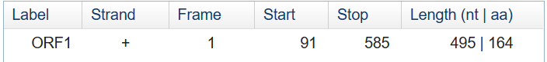
REASON FOR SELECTING ORF
Although the full DNA sequence is 2117 bp long, not all regions are protein-coding. ORF Finder was used to identify potential coding regions. ORF1 was selected because it contains a canonical ATG start codon, a proper in-frame stop codon, is located on the positive strand, and has a length of 495 bp encoding a 164-amino-acid protein. A minimum cutoff of 300 bp was applied to avoid short, non-functional ORFs, making this ORF the most biologically relevant candidate for further analysis.

